Задача "Обновление версии ОС на сервере ds-pr-sp-01" (https://jira.tcsbank.ru/browse/IN-1089).
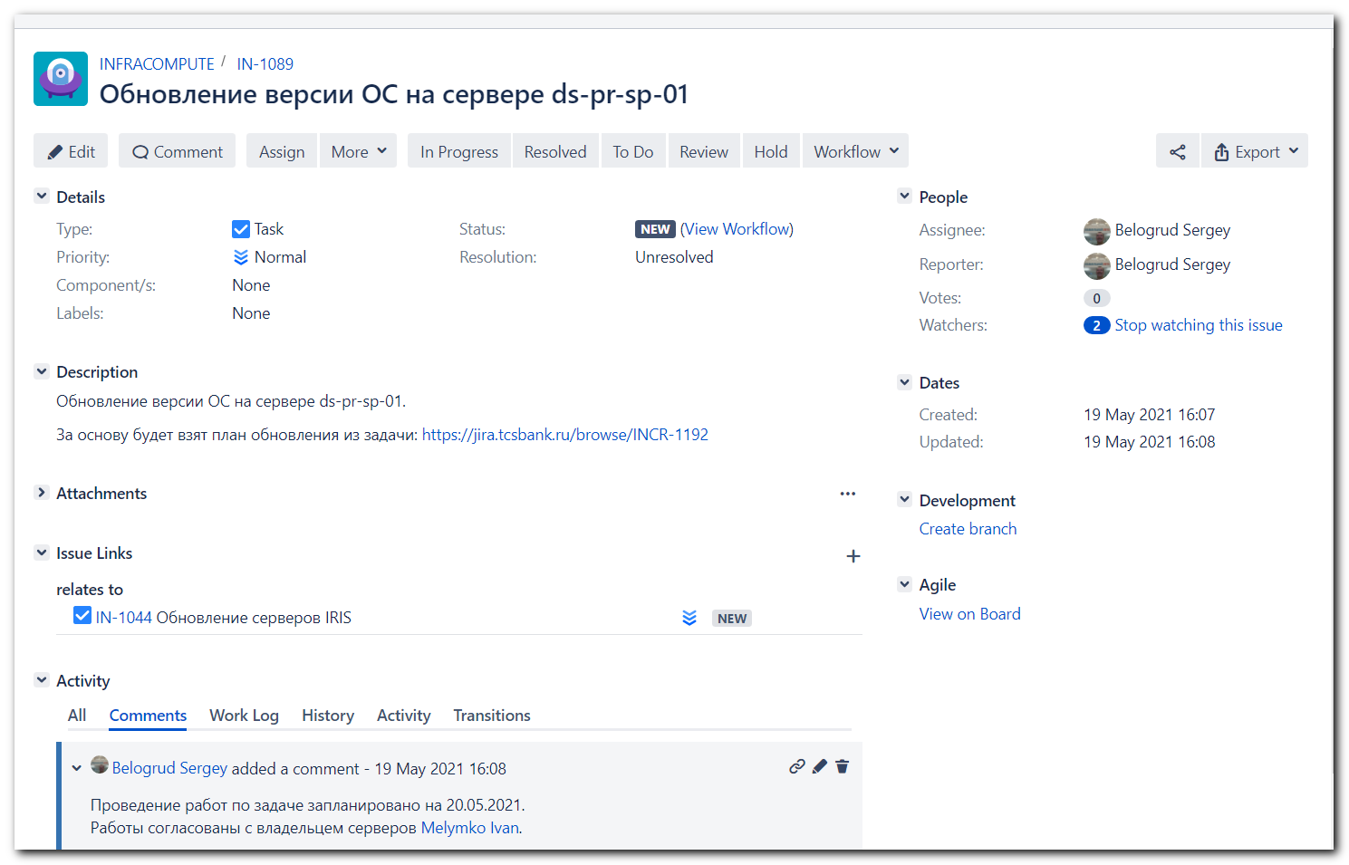

[s.belogrud@nb2339]# ssh s_s.belogrud@ds-pr-sp-01
Creating home directory for s_s.belogrud.
[s_s.belogrud@ds-pr-sp-01 ~]$ sudo -i

We trust you have received the usual lecture from the local System
Administrator. It usually boils down to these three things:

#1) Respect the privacy of others.
#2) Think before you type.
#3) With great power comes great responsibility.

[sudo] password for s_s.belogrud:
[root@ds-pr-sp-01 ~]#
[root@ds-pr-sp-01 ~]# cat /etc/redhat-release
Red Hat Enterprise Linux Server release 7.7 (Maipo)
[root@ds-pr-sp-01 ~]# subscription-manager status
+-------------------------------------------+
System Status Details
+-------------------------------------------+
Overall Status: Unknown

System Purpose Status: Unknown

[root@ds-pr-sp-01 ~]#
[root@ds-pr-sp-01 ~]#
[root@ds-pr-sp-01 ~]# egrep -e "^proxy_hostname|^proxy_port|^proxy_user|^proxy_password" /etc/rhsm/rhsm.conf
proxy_hostname =
proxy_port =
proxy_user =
proxy_password =
[root@ds-pr-sp-01 ~]# vim /etc/rhsm/rhsm.conf
[root@ds-pr-sp-01 ~]# egrep -e "^proxy_hostname|^proxy_port|^proxy_user|^proxy_password" /etc/rhsm/rhsm.conf
proxy_hostname = proxy.tcsbank.ru
proxy_port = 8080
proxy_user = rhsm_user
proxy_password =6eKoEvNHFS5IycxhqH5W
[root@ds-pr-sp-01 ~]#

[root@ds-pr-sp-01 ~]# read -s -p "Enter RHN Password: " RHN_PASSWORD ; subscription-manager register --username=tcsbank17012012 --password=$RHN_PASSWORD --auto-attach
Enter RHN Password: Registering to: subscription.rhsm.redhat.com:443/subscription
The system has been registered with ID: fe9038ac-7540-4b6b-b2d1-64377d5361e2
The registered system name is: ds-pr-sp-01.tcsbank.ru
Installed Product Current Status:
Product Name: Red Hat Enterprise Linux Server
Status: Subscribed

[root@ds-pr-sp-01 ~]# subscription-manager status
+-------------------------------------------+
System Status Details
+-------------------------------------------+
Overall Status: Current

System Purpose Status: Not Specified

[root@ds-pr-sp-01 ~]# subscription-manager identity
system identity: fe9038ac-7540-4b6b-b2d1-64377d5361e2
name: ds-pr-sp-01.tcsbank.ru
org name: 6534084
org ID: 6534084
[root@ds-pr-sp-01 ~]#

[root@ds-pr-sp-01 ~]# subscription-manager release --list
+-------------------------------------------+
Available Releases
+-------------------------------------------+
7.0
7.1
7.2
7.3
7.4
7.5
7.6
7.7
7.8
7.9
7Server
[root@ds-pr-sp-01 ~]#

[root@ds-pr-sp-01 ~]# subscription-manager release --set 7.9
Release set to: 7.9
[root@ds-pr-sp-01 ~]#

[root@ds-pr-sp-01 ~]# ls -Alh /etc/yum.repos.d/
total 256K
-rw-r--r-- 1 root root 235K May 19 16:56 redhat.repo
-rw-r--r-- 1 root root 145 Oct 30 2019 tcs-centos.repo
-rw-r--r-- 1 root root 150 Oct 30 2019 tcs-epel.repo
-rw-r--r-- 1 root root 135 Sep 8 2020 tcs-influx.repo
-rw-r--r-- 1 root root 165 Oct 30 2019 tcs-ius.repo
-rw-r--r-- 1 root root 185 Oct 30 2019 tcs-rhel-server-rpms.repo
[root@ds-pr-sp-01 ~]#

[root@ds-pr-sp-01 ~]# mkdir -p ~/work/20210519-1657/backup
[root@ds-pr-sp-01 ~]# cp /etc/yum.repos.d/* ~/work/20210519-1657/backup/
[root@ds-pr-sp-01 ~]# vim -R /etc/yum.repos.d/redhat.repo
[root@ds-pr-sp-01 ~]# yum repolist
Loaded plugins: fastestmirror, langpacks, product-id, search-disabled-repos, subscription-manager
Determining fastest mirrors
centos | 3.6 kB 00:00:00
epel | 4.7 kB 00:00:00
ius | 2.9 kB 00:00:00
rhel-7-server-rpms | 3.5 kB 00:00:00
rhel-server-rpms | 3.0 kB 00:00:00
tcs-influxdb | 2.5 kB 00:00:00
(1/11): centos/x86_64/group_gz | 153 kB 00:00:00
(2/11): epel/x86_64/group_gz | 96 kB 00:00:00
(3/11): centos/x86_64/primary_db | 6.1 MB 00:00:00
(4/11): ius/primary_db | 377 kB 00:00:00
(5/11): epel/x86_64/updateinfo | 1.0 MB 00:00:00
(6/11): epel/x86_64/primary_db | 6.9 MB 00:00:00
(7/11): rhel-7-server-rpms/x86_64/group | 631 kB 00:00:00
(8/11): rhel-7-server-rpms/x86_64/updateinfo | 4.0 MB 00:00:00
(9/11): rhel-server-rpms/7Server/x86_64/primary_db | 76 MB 00:00:00
(10/11): tcs-influxdb/primary_db | 55 kB 00:00:00
(11/11): rhel-7-server-rpms/x86_64/primary_db | 81 MB 00:00:01
repo id repo name status
centos/x86_64 CentOS-7Server - Base 10,072
epel/x86_64 Extra Packages for Enterprise Linux 7 13,592
ius IUS Community Packages for Enterprise Linux 7 - x86_64 713
rhel-7-server-rpms/x86_64 Red Hat Enterprise Linux 7 Server (RPMs) 31,775
rhel-server-rpms/7Server/x86_64 Red Hat Enterprise Linux 7Server Server (RPMs) 34,920
tcs-influxdb tcs-influxdb 231
repolist: 91,303
[root@ds-pr-sp-01 ~]# yum clean all
Loaded plugins: fastestmirror, langpacks, product-id, search-disabled-repos, subscription-manager
Cleaning repos: centos epel ius rhel-7-server-rpms rhel-server-rpms tcs-influxdb
Cleaning up list of fastest mirrors
Other repos take up 596 M of disk space (use --verbose for details)
[root@ds-pr-sp-01 ~]# rm -rf /var/cache/yum
[root@ds-pr-sp-01 ~]#

[root@ds-pr-sp-01 ~]# ls -Alh /etc/yum.repos.d/
total 236K
-rw-r--r-- 1 root root 235K May 19 16:56 redhat.repo
[root@ds-pr-sp-01 ~]# yum repolist
Loaded plugins: fastestmirror, langpacks, product-id, search-disabled-repos, subscription-manager
Determining fastest mirrors
rhel-7-server-rpms | 3.5 kB 00:00:00
(1/3): rhel-7-server-rpms/x86_64/group | 631 kB 00:00:00
(2/3): rhel-7-server-rpms/x86_64/updateinfo | 4.0 MB 00:00:00
(3/3): rhel-7-server-rpms/x86_64/primary_db | 81 MB 00:00:01
repo id repo name status
rhel-7-server-rpms/x86_64 Red Hat Enterprise Linux 7 Server (RPMs) 31,775
repolist: 31,775
[root@ds-pr-sp-01 ~]#

[root@ds-pr-sp-01 ~]# yum update
...
--> Finished Dependency Resolution
Error: Package: libreport-centos-2.1.11-43.el7.centos.x86_64 (@centos)
Requires: libreport = 2.1.11-43.el7.centos
Removing: libreport-2.1.11-43.el7.centos.x86_64 (@centos)
libreport = 2.1.11-43.el7.centos
Updated By: libreport-2.1.11-53.el7.x86_64 (rhel-7-server-rpms)
libreport = 2.1.11-53.el7
Available: libreport-2.1.11-10.el7.i686 (rhel-7-server-rpms)
libreport = 2.1.11-10.el7
Available: libreport-2.1.11-21.el7.i686 (rhel-7-server-rpms)
libreport = 2.1.11-21.el7
Available: libreport-2.1.11-23.el7_1.i686 (rhel-7-server-rpms)
libreport = 2.1.11-23.el7_1
Available: libreport-2.1.11-30.el7.i686 (rhel-7-server-rpms)
libreport = 2.1.11-30.el7
Available: libreport-2.1.11-31.el7.i686 (rhel-7-server-rpms)
libreport = 2.1.11-31.el7
Available: libreport-2.1.11-35.el7.i686 (rhel-7-server-rpms)
libreport = 2.1.11-35.el7
Available: libreport-2.1.11-38.el7.i686 (rhel-7-server-rpms)
libreport = 2.1.11-38.el7
...
Error: Package: libreport-plugin-mantisbt-2.1.11-43.el7.centos.x86_64 (@centos)
Requires: libreport-web = 2.1.11-43.el7.centos
Removing: libreport-web-2.1.11-43.el7.centos.x86_64 (@centos)
libreport-web = 2.1.11-43.el7.centos
...
Error: Package: abrt-retrace-client-2.1.11-55.el7.centos.x86_64 (@centos)
Requires: abrt = 2.1.11-55.el7.centos
Removing: abrt-2.1.11-55.el7.centos.x86_64 (@centos)
abrt = 2.1.11-55.el7.centos
...
Error: Package: libreport-centos-2.1.11-43.el7.centos.x86_64 (@centos)
Requires: libreport-web = 2.1.11-43.el7.centos
Removing: libreport-web-2.1.11-43.el7.centos.x86_64 (@centos)
libreport-web = 2.1.11-43.el7.centos
Updated By: libreport-web-2.1.11-53.el7.x86_64 (rhel-7-server-rpms)
...
Error: Package: libreport-plugin-mantisbt-2.1.11-43.el7.centos.x86_64 (@centos)
Requires: libreport = 2.1.11-43.el7.centos
Removing: libreport-2.1.11-43.el7.centos.x86_64 (@centos)
libreport = 2.1.11-43.el7.centos
...
**********************************************************************
yum can be configured to try to resolve such errors by temporarily enabling
disabled repos and searching for missing dependencies.
To enable this functionality please set 'notify_only=0' in /etc/yum/pluginconf.d/search-disabled-repos.conf
**********************************************************************

Error: Package: libreport-centos-2.1.11-43.el7.centos.x86_64 (@centos)
Requires: libreport = 2.1.11-43.el7.centos
Removing: libreport-2.1.11-43.el7.centos.x86_64 (@centos)
libreport = 2.1.11-43.el7.centos
...
Error: Package: libreport-plugin-mantisbt-2.1.11-43.el7.centos.x86_64 (@centos)
Requires: libreport-web = 2.1.11-43.el7.centos
Removing: libreport-web-2.1.11-43.el7.centos.x86_64 (@centos)
libreport-web = 2.1.11-43.el7.centos
...
Error: Package: libreport-centos-2.1.11-43.el7.centos.x86_64 (@centos)
Requires: libreport-web = 2.1.11-43.el7.centos
Removing: libreport-web-2.1.11-43.el7.centos.x86_64 (@centos)
...
Error: Package: libreport-plugin-mantisbt-2.1.11-43.el7.centos.x86_64 (@centos)
Requires: libreport = 2.1.11-43.el7.centos
Removing: libreport-2.1.11-43.el7.centos.x86_64 (@centos)
libreport = 2.1.11-43.el7.centos
...
You could try using --skip-broken to work around the problem
You could try running: rpm -Va --nofiles --nodigest
[root@ds-pr-sp-01 ~]#

[root@ds-pr-sp-01 ~]# cp ~/work/20210519-1657/backup/tcs-centos.repo /etc/yum.repos.d/
[root@ds-pr-sp-01 ~]#

[root@ds-pr-sp-01 ~]# yum repolist
Loaded plugins: fastestmirror, langpacks, product-id, search-disabled-repos, subscription-manager
Loading mirror speeds from cached hostfile
centos | 3.6 kB 00:00:00
(1/2): centos/x86_64/group_gz | 153 kB 00:00:00
(2/2): centos/x86_64/primary_db | 6.1 MB 00:00:00
repo id repo name status
centos/x86_64 CentOS-7Server - Base 10,072
rhel-7-server-rpms/x86_64 Red Hat Enterprise Linux 7 Server (RPMs) 31,775
repolist: 41,847
[root@ds-pr-sp-01 ~]#

#
# Here are too many packages took from CentOS repository.
# And more packages previously installed from RHN are change their source to CentOS.
# This is not good at all.
#
[root@ds-pr-sp-01 ~]# yum update
Loaded plugins: fastestmirror, langpacks, product-id, search-disabled-repos, subscription-manager
Loading mirror speeds from cached hostfile
Resolving Dependencies
--> Running transaction check
---> Package NetworkManager.x86_64 1:1.18.0-5.el7_7.2 will be updated
...
Dependencies Resolved

=========================================================================================================================================================
Package Arch Version Repository Size
=========================================================================================================================================================
Installing:
iwl7260-firmware noarch 25.30.13.0-80.el7_9 rhel-7-server-rpms 6.1 M
replacing iwl7265-firmware.noarch 22.0.7.0-72.el7
kernel x86_64 3.10.0-1160.25.1.el7 rhel-7-server-rpms 50 M
Updating:
NetworkManager x86_64 1:1.18.8-2.el7_9 rhel-7-server-rpms 1.9 M
NetworkManager-config-server noarch 1:1.18.8-2.el7_9 rhel-7-server-rpms 151 k
NetworkManager-libnm x86_64 1:1.18.8-2.el7_9 rhel-7-server-rpms 1.7 M
NetworkManager-team x86_64 1:1.18.8-2.el7_9 rhel-7-server-rpms 165 k
NetworkManager-tui x86_64 1:1.18.8-2.el7_9 rhel-7-server-rpms 329 k
abrt x86_64 2.1.11-60.el7.centos centos 538 k
abrt-addon-ccpp x86_64 2.1.11-60.el7.centos centos 195 k
abrt-addon-kerneloops x86_64 2.1.11-60.el7.centos centos 107 k
abrt-addon-pstoreoops x86_64 2.1.11-60.el7.centos centos 97 k
abrt-addon-python x86_64 2.1.11-60.el7.centos centos 103 k
abrt-addon-vmcore x86_64 2.1.11-60.el7.centos centos 107 k
abrt-addon-xorg x86_64 2.1.11-60.el7.centos centos 98 k
...
chkconfig x86_64 1.7.6-1.el7 centos 182 k
...
Installing for dependencies:
gnutls x86_64 3.3.29-9.el7_6 centos 680 k
nettle x86_64 2.7.1-9.el7_9 rhel-7-server-rpms 328 k
trousers x86_64 0.3.14-2.el7 centos 289 k

Transaction Summary
=========================================================================================================================================================
Install 2 Packages (+3 Dependent packages)
Upgrade 324 Packages

Total download size: 433 M
Is this ok [y/d/N]: d
Background downloading packages, then exiting:
Delta RPMs disabled because /usr/bin/applydeltarpm not installed.
warning: /var/cache/yum/x86_64/7Server/rhel-7-server-rpms/packages/NetworkManager-1.18.8-2.el7_9.x86_64.rpm: Header V3 RSA/SHA256 Signature, key ID fd431
d51: NOKEY
Public key for NetworkManager-1.18.8-2.el7_9.x86_64.rpm is not installed
(1/329): NetworkManager-1.18.8-2.el7_9.x86_64.rpm | 1.9 MB 00:00:00
(2/329): NetworkManager-config-server-1.18.8-2.el7_9.noarch.rpm | 151 kB 00:00:00
...
(328/329): zlib-1.2.7-19.el7_9.x86_64.rpm | 90 kB 00:00:00
(329/329): yum-utils-1.1.31-54.el7_8.noarch.rpm | 122 kB 00:00:00
---------------------------------------------------------------------------------------------------------------------------------------------------------
Total 3.4 MB/s | 433 MB 00:02:05
exiting because "Download Only" specified
[root@ds-pr-sp-01 ~]#

# At this moment this package was installed from RHN.
[root@ds-pr-sp-01 ~]# rpm -qi chkconfig
Name : chkconfig
Version : 1.7.4
Release : 1.el7
Architecture: x86_64
Install Date: Tue 22 Oct 2019 02:41:04 PM MSK
Group : System Environment/Base
Size : 779539
License : GPLv2
Signature : RSA/SHA256, Tue 06 Jun 2017 02:19:25 PM MSK, Key ID 199e2f91fd431d51
Source RPM : chkconfig-1.7.4-1.el7.src.rpm
Build Date : Tue 06 Jun 2017 02:05:43 PM MSK
Build Host : x86-030.build.eng.bos.redhat.com
Relocations : (not relocatable)
Packager : Red Hat, Inc. <http://bugzilla.redhat.com/bugzilla>
Vendor : Red Hat, Inc.
URL : https://github.com/fedora-sysv/chkconfig
Summary : A system tool for maintaining the /etc/rc*.d hierarchy
Description :
Chkconfig is a basic system utility. It updates and queries runlevel
information for system services. Chkconfig manipulates the numerous
symbolic links in /etc/rc.d, to relieve system administrators of some
of the drudgery of manually editing the symbolic links.
[root@ds-pr-sp-01 ~]#

#
# Here I testing to remove troubled packages before.
# I hope packages, that were installed from CentOS repository not too many. And I would remove them manually.
#
[root@ds-pr-sp-01 ~]# yum remove libreport-centos
Loaded plugins: fastestmirror, langpacks, product-id, search-disabled-repos, subscription-manager
Resolving Dependencies
--> Running transaction check
---> Package libreport-centos.x86_64 0:2.1.11-43.el7.centos will be erased
--> Processing Dependency: libreport-centos >= 2.1.11-43 for package: abrt-cli-2.1.11-55.el7.centos.x86_64
--> Running transaction check
---> Package abrt-cli.x86_64 0:2.1.11-55.el7.centos will be erased
--> Processing Dependency: abrt-cli = 2.1.11-55.el7.centos for package: abrt-console-notification-2.1.11-55.el7.centos.x86_64
--> Running transaction check
---> Package abrt-console-notification.x86_64 0:2.1.11-55.el7.centos will be erased
--> Finished Dependency Resolution

Dependencies Resolved

=========================================================================================================================================================
Package Arch Version Repository Size
=========================================================================================================================================================
Removing:
libreport-centos x86_64 2.1.11-43.el7.centos @centos 34 k
Removing for dependencies:
abrt-cli x86_64 2.1.11-55.el7.centos @centos 0.0
abrt-console-notification x86_64 2.1.11-55.el7.centos @centos 1.3 k

Transaction Summary
=========================================================================================================================================================
Remove 1 Package (+2 Dependent packages)

Installed size: 35 k
Is this ok [y/N]: N
Exiting on user command
Your transaction was saved, rerun it with:
yum load-transaction /tmp/yum_save_tx.2021-05-19.17-58.0HrW7p.yumtx
[root@ds-pr-sp-01 ~]#

[root@ds-pr-sp-01 ~]# yum repolist
Loaded plugins: fastestmirror, langpacks, product-id, search-disabled-repos, subscription-manager
Loading mirror speeds from cached hostfile
repo id repo name status
centos/x86_64 CentOS-7Server - Base 10,072
rhel-7-server-rpms/x86_64 Red Hat Enterprise Linux 7 Server (RPMs) 31,775
repolist: 41,847
[root@ds-pr-sp-01 ~]# yum update --disablerepo="*" --enablerepo="rhel-7-server-rpms"
Loaded plugins: fastestmirror, langpacks, product-id, search-disabled-repos, subscription-manager
Loading mirror speeds from cached hostfile
Resolving Dependencies
--> Running transaction check
---> Package NetworkManager.x86_64 1:1.18.0-5.el7_7.2 will be updated
...

[root@ds-pr-sp-01 ~]# reboot
Connection to ds-pr-sp-01 closed by remote host.
Connection to ds-pr-sp-01 closed.
[s.belogrud@nb2339]#

[root@ds-pr-sp-01 ~]# ls -Alh /etc/yum.repos.d/
total 240K
-rw-r--r-- 1 root root 235K May 20 11:09 redhat.repo
-rw-r--r-- 1 root root 145 May 19 17:46 tcs-centos.repo
[root@ds-pr-sp-01 ~]# rm /etc/yum.repos.d/tcs-centos.repo
rm: remove regular file ‘/etc/yum.repos.d/tcs-centos.repo’? y
[root@ds-pr-sp-01 ~]#

[root@ds-pr-sp-01 ~]# yum clean all
Loaded plugins: fastestmirror, langpacks, product-id, search-disabled-repos, subscription-manager
Cleaning repos: rhel-7-server-rpms
Cleaning up list of fastest mirrors
Other repos take up 179 M of disk space (use --verbose for details)
[root@ds-pr-sp-01 ~]# yum repolist
Loaded plugins: fastestmirror, langpacks, product-id, search-disabled-repos, subscription-manager
Determining fastest mirrors
rhel-7-server-rpms | 3.5 kB 00:00:00
(1/3): rhel-7-server-rpms/x86_64/updateinfo | 4.0 MB 00:00:00
(2/3): rhel-7-server-rpms/x86_64/group | 631 kB 00:00:01
(3/3): rhel-7-server-rpms/x86_64/primary_db | 81 MB 00:00:02
repo id repo name status
rhel-7-server-rpms/x86_64 Red Hat Enterprise Linux 7 Server (RPMs) 31,775
repolist: 31,775
[root@ds-pr-sp-01 ~]#

[root@ds-pr-sp-01 ~]# yum update

[root@ds-pr-sp-01 ~]# reboot
Connection to ds-pr-sp-01 closed by remote host.
Connection to ds-pr-sp-01 closed.
[s.belogrud@nb2339]#

[root@ds-pr-sp-01 ~]# cat /etc/redhat-release
Red Hat Enterprise Linux Server release 7.9 (Maipo)
[root@ds-pr-sp-01 ~]# uname -a
Linux ds-pr-sp-01.tcsbank.ru 3.10.0-1160.25.1.el7.x86_64 #1 SMP Tue Apr 13 18:55:45 EDT 2021 x86_64 x86_64 x86_64 GNU/Linux
[root@ds-pr-sp-01 ~]#

[root@ds-pr-sp-01 ~]# cp ~/work/20210519-1657/backup/tcs-influx.repo /etc/yum.repos.d/
[root@ds-pr-sp-01 ~]# yum repolist
Loaded plugins: fastestmirror, langpacks, product-id, search-disabled-repos, subscription-manager

This system is not registered with an entitlement server. You can use subscription-manager to register.

Loading mirror speeds from cached hostfile
tcs-influxdb | 2.5 kB 00:00:00
tcs-influxdb/primary_db | 55 kB 00:00:00
repo id repo name status
tcs-epel/7Server/x86_64 Extra Packages for Enterprise Linux 7Server - x86_64 13,592
tcs-influxdb tcs-influxdb 231
tcs-rhel-base/7Server/x86_64 Red Hat Enterprise Linux Server Base(v. 6/7 for x86_64) 34,920
tcs-rhel-extras/7Server Red Hat Enterprise Linux Server Extras(v. 6/7 for x86_64) 1,356
tcs-rhel-optional/7Server Red Hat Enterprise Linux Server Optional(v. 6/7 for x86_64) 17,595
repolist: 67,694
[root@ds-pr-sp-01 ~]#

[support@nb2339]# export ANSIBLE_CONFIG=ansible.cfg ; logfile="$(date +%Y%m%d-%H%M).playbook.log.txt" ; ansible-playbook 20210302-1613.repository.yml -i list_of_hosts --become --extra-vars "ansible_user=bsv ansible_password=$(pass common/linux-bsv) ansible_sudo_pass=$(pass common/linux-bsv) ansible_ssh_common_args='-oStrictHostKeyChecking=no -oPubkeyAuthentication=no -oUserKnownHostsFile=/dev/null'" | tee -a ./output/${logfile}

#
# 20210526
# Unexpectedly stop working iLO on this server.
# Nagios check became brown - UNKNOWN.
# Web interface of iLO was unavailable via web-browser too.
#

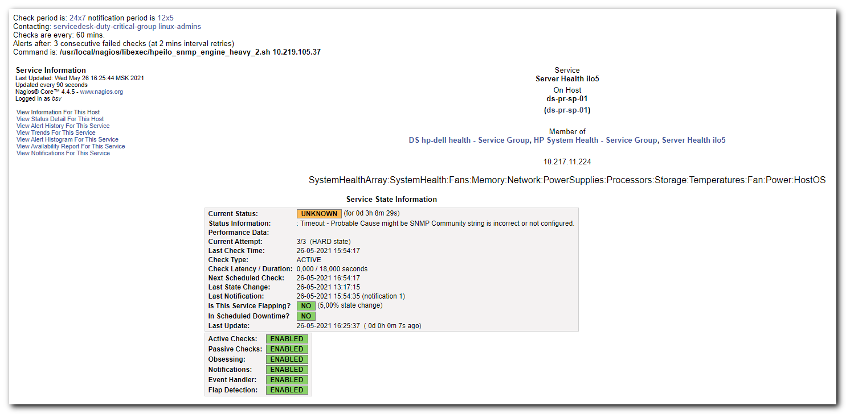
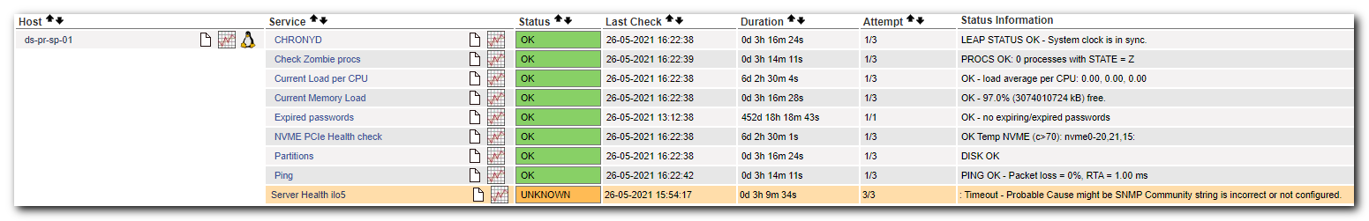

[s.belogrud@nb2339]# ssh s_s.belogrud@nag-tst
Creating directory '/home/idm/s_s.belogrud'.
[s_s.belogrud@vd-nag4-tst-1 ~]$ /usr/local/nagios/libexec/hpeilo_snmp_engine_heavy_2.sh 10.219.105.37
Timeout: No Response from 10.219.105.37.
: Timeout - Probable Cause might be SNMP Community string is incorrect or not configured.
[s_s.belogrud@vd-nag4-tst-1 ~]$

#
# iLO interface was awailable for ping.
#
[s.belogrud@nb2339]# ping 10.219.105.37

Обмен пакетами с 10.219.105.37 по с 32 байтами данных:
Ответ от 10.219.105.37: число байт=32 время=6мс TTL=249
Ответ от 10.219.105.37: число байт=32 время=10мс TTL=249
Ответ от 10.219.105.37: число байт=32 время=5мс TTL=249

[s.belogrud@nb2339]#

#
# I decided to reboot iLO.
# But I couldn't remember how to do that.
# I decided to install appropriate utilities.
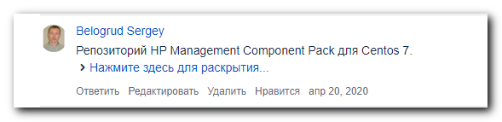
[root@ds-pr-sp-01 ~]# cat > /etc/yum.repos.d/tcs-nexus-hp-mcp.repo
[tcs-nexus-hp-mcp]
name=Management Component Pack
baseurl=http://repo-linux.tcsbank.ru/repository/hp/repo/mcp/centos/7/x86_64/current
enabled=1
gpgcheck=0
gpgkey=file:///etc/pki/rpm-gpg/GPG-KEY-mcp
[root@ds-pr-sp-01 ~]#

[root@ds-pr-sp-01 ~]# yum repolist
[root@ds-pr-sp-01 ~]# yum install hponcfg

[root@ds-pr-sp-01 ~]# hponcfg
HP Lights-Out Online Configuration utility
Version 5.5.0 Date 5/30/2019 (c) 2005,2019 Hewlett Packard Enterprise Development LP
Firmware Revision = 1.45 Device type = iLO 5 Driver name = hpilo

USAGE:
hponcfg -?
hponcfg -h
hponcfg -m minFw
hponcfg -r [-m minFw] [-u username] [-p password]
hponcfg -b [-m minFw] [-u username] [-p password]
hponcfg [-a] -w filename [-m minFw] [-u username] [-p password]
hponcfg -g [-m minFw] [-u username] [-p password]
hponcfg -f filename [-l filename] [-s namevaluepair] [-v] [-m minFw] [-u username] [-p password]
hponcfg -i [-l filename] [-s namevaluepair] [-v] [-m minFw] [-u username] [-p password]

-h, --help Display this message
-? Display this message
-r, --reset Reset the Management Processor to factory defaults
-b, --reboot Reboot Management Processor without changing any setting
-f, --file Get/Set Management Processor configuration from "filename"
-i, --input Get/Set Management Processor configuration from the XML input
received through the standard input stream.
-w, --writeconfig Write the Management Processor configuration to "filename"
-a, --all Capture complete Management Processor configuration to the file.
This should be used along with '-w' option
-l, --log Log replies to "filename"
-v, --xmlverbose Display all the responses from Management Processor
-s, --substitute Substitute variables present in input config file
with values specified in "namevaluepairs"
-g, --get_hostinfo Get the Host information
-m, --minfwlevel Minimum firmware level
-u, --username iLO Username
-p, --password iLO Password
[root@ds-pr-sp-01 ~]#

[root@ds-pr-sp-01 ~]# hponcfg --reboot
HP Lights-Out Online Configuration utility
Version 5.5.0 Date 5/30/2019 (c) 2005,2019 Hewlett Packard Enterprise Development LP
Firmware Revision = 1.45 Device type = iLO 5 Driver name = hpilo
Rebooting the Management Processor...This takes upto 60 seconds.
The Management Processor has been rebooted.
[root@ds-pr-sp-01 ~]#

#
# I hopefully rebooted iLO on the server and it started work correctly again.
#
[s_s.belogrud@vd-nag4-tst-1 ~]$ /usr/local/nagios/libexec/hpeilo_snmp_engine_heavy_2.sh 10.219.105.37
CZ292501CZ.mgmt.tcsbank.ru : OK
[s_s.belogrud@vd-nag4-tst-1 ~]$

